INDIRA GANDHI NATIONAL OPEN UNIVERSITY

JOB HUNTER
By
SIDDARTH
Under Guidance Of
RITESH KUMAR

Submitted to the School of Computer and Information Sciences
in partial fulfillment of the requirements
for the degree of

BACHELOR
of
COMPUTER APPLICATIONS

Indira Gandhi National Open University
New Delhi – 110067.
SCHOOL OF COMPUTER AND INFORMATION SCIENCES

IGNOU, MAIDAN GARHI, NEW DELHI – 110 068

PROFORMA FOR SUGGESTIONS OF MCA-44 PROJECT PROPOSAL

(Note: All entries of the proforma of suggestions should be filled in with appropriate and
complete information. Incomplete proforma of suggestions in any respect will be summarily rejected.)

Enrolment No.: …………………………
Study Centre: ……………….………….
Regional Centre:………RC-Code:…….
E-mail: ………….………..…………........
Telephone No.: …………………………

1. Name and Address of the student ………………………..…………………………………….

2. Title of the Project ……………..………..…………………………………………………….…

3. Name and Address of the Counsellor……..…………………………………………………….

Ph.D* M.Tech.* B.E*/B.Tech.* MCA M.Sc.*
4. Educational Qualification of the Guide
(Attach bio-data also)

(*in Computer Science / IT only)
5. Working / Teaching experience of the Guide** …………………………………………………………………………………
6. Software used in the project ………………………………………………………………………………………………………………
Signature of the Student Signature of the Counselor
Date: ………………… Date: …………………….

Suggestions for reformulating the Project :

CERTIFICATE OF AUTHENTICATED WORK

This is to certify that the project report entitled _________________________ submitted to
Indira Gandhi National Open University in partial fulfillment of the requirement for the award

of the degree of MASTER OF COMPUTER APPLICATIONS (MCA) is an original work

carried out by Mr./ Ms._______________________ enrolment no. _____________ under my

guidance. The matter embodied in this project is authentic and is genuine work done by the

student and has not been submitted whether to this University or to any other University /

Institute for the fulfilment of the requirement of any course of study.

………………………. ...…………………….
Signature of the Student: Signature of the Guide

Date: ……………….. Date: ………………

Name and Address Name, Designation
of the student and Address of the
Guide:
……………………….. ………………………..
……………………….. ………………………..
……………………….. ………………………..
……………………….. ………………………..

Enrolment No…………

JOB HUNTER SYSTEM

A
Synopsis
Of
BCA Semester - 5

Job Hunter System

SUBMITTED BY
NAME : | SIDDARTH
ENLORMENT NO : | 2352248276

INDEX OF SYNONIS
Contents | Page no.
1.Title of the project
2. Introduction
3. Background
4. Objective and Scope of the project
5. Survey of Technology
6. Project Category
7. Tools/platform, Hardware and software requirement specifications
8. Analysis
9. Data Flow Diagram
10. ER-Diagram
11. Data Modeling
12. Project Planning and Scheduling
13. Process Logic
14. Report Generation
15. Testing Method
16. Conclusion
17. Scope of future application
18. Bibliography

JOB HUNTER

(ONLINE JOB SEARCHING AND CANDIDATE HERING SYSTEM)
INTRODUCTION
- In today’s technology-driven world, job searching and recruitment processes are rapidly shifting toward online and digital platforms. Traditional methods such as newspaper advertisements, manual job applications, and walk-in interviews are not only time-consuming but also inefficient and limited in reach. These methods often result in delayed communication, lack of transparency, and difficulty in tracking job opportunities and applications. As the number of job seekers and organizations continues to grow, there is a strong need for a centralized and automated system that can simplify and improve the overall recruitment process.
- To overcome these limitations, the Job Hunter System is proposed as a web-based application that provides an effective, reliable, and user-friendly platform for both job seekers and recruiters. The system enables job seekers to register, create detailed profiles, upload resumes, search for suitable job opportunities, and apply for jobs online with ease. At the same time, recruiters and employers can post job vacancies, manage applications, review candidate profiles, and shortlist applicants efficiently through a single platform.
- The Job Hunter System is developed using the MERN Stack (MongoDB, Express.js, React.js, and Node.js), which ensures high performance, scalability, and real-time interaction. React.js provides a responsive and interactive user interface, while Node.js and Express.js handle server-side logic and API management. MongoDB is used for secure and flexible data storage of user profiles, job postings, and applications. Together, these technologies make the system fast, secure, and capable of handling a large number of users simultaneously. Overall, the Job Hunter System aims to modernize the recruitment process by reducing manual effort,
OBJECTION
The main objective of this project is to transform the existing manual job searching and hiring system into a fully computerized and online system. The proposed software is designed to provide a user-friendly environment, ensuring that it is easy to use and not complicated for job seekers, recruiters, and administrators.
This project is highly useful for organizations, companies, placement cells, and job seekers where regular recruitment and hiring activities are required.
- To develop an online system for job searching and hiring
- To reduce dependency on traditional manual recruitment methods
- To minimize time consumption in job searching, application submission, and hiring processes
- To reduce paperwork by maintaining all recruitment-related data digitally
- To allow job seekers to register, create profiles, upload resumes, and apply for jobs online
- To enable employers and HR departments to post job vacancies and manage applications
- To provide real-time updates on job applications and hiring status
- To allow administrators to manage users, job postings, and system operations
- To generate various reports related to job postings, applications, and recruitment activities whenever required
- To improve accuracy, reliability, and transparency in the hiring process
- To save operational costs and reduce the consumption of natural resources by eliminating paper-based processes
- To help job seekers understand their eligibility, opportunities, and application status without long waiting periods
SURVEY OF TECHNOLOGY
In the present technology-driven era, information technology plays a vital role in almost every field, including job searching and recruitment. Earlier, job searching and hiring processes were mainly carried out using traditional methods such as newspaper advertisements, manual resume submission, notice boards, and personal references. These methods required a large amount of paperwork, human effort, and time, and often resulted in delayed responses and inefficient management of candidate information.
With the rapid development of computer systems and widespread availability of the internet, organizations have started adopting online platforms to manage recruitment activities. Today, a large percentage of people are familiar with computers, mobile devices, websites, and web-based applications. The internet has become one of the fastest and most reliable mediums for sharing information, making it possible to connect job seekers and recruiters across different locations in a short period of time.
Modern recruitment systems use web technologies to store, process, and manage large amounts of data efficiently. Online job portals allow job seekers to register, create profiles, upload resumes, search for job opportunities, and apply for jobs from anywhere at any time. Similarly, recruiters can post job vacancies, review applications, shortlist candidates, and communicate with applicants through a centralized system. This reduces manual work and improves the overall efficiency of the hiring process.
The Job Hunter System uses modern web technologies to provide a secure and user-friendly platform for job searching and hiring. It replaces manual recruitment with a faster, more accurate, and cost-effective digital process.

PROJECT CATEGORY
Database Management System (NoSQL – MongoDB)
The proposed Job Hunter System comes under the Database Management System category and is implemented using MongoDB, a NoSQL database. The system is required to store, retrieve, and manage a large amount of data related to job seekers, recruiters, job postings, applications, resumes, and hiring status. Since the data is continuously updated and accessed by multiple users, an efficient and scalable database system is essential.
MongoDB provides a flexible schema design that allows easy modification and expansion of data structures as per project requirements. It supports fast data retrieval, high performance, and scalability, which makes it suitable for handling real-time web applications. The use of MongoDB also improves data availability, security, and reliability. Therefore, using a NoSQL database like MongoDB makes the Job Hunter System efficient, scalable, and well-suited for an online job searching and hiring platform.

SOFTARE AND HARDWARE

Software Requirements
The Job Hunter System is developed using modern web technologies for both frontend and backend, along with a database to manage user and job-related data efficiently. The following software components are required:
Component | Technology / Tool | Description
Frontend | HTML5, CSS3, JavaScript, React.js, Bootstrap | Used to design a responsive and interactive user interface for job seekers, recruiters, and administrators.
Backend | Node.js, Express.js | Provides server-side functionality, handles API requests, and manages application logic.
Database | MongoDB | A NoSQL database used to store and manage large volumes of structured and unstructured data, including user profiles, job postings, and applications.
Operating System | Windows XP, Windows 7 or later | Required to install development tools, runtime environments, and web servers for the application.

Hardware Requirements
The following hardware specifications are recommended to efficiently run and test the Job Hunter System:
Component | Specification | Description
Processor | Pentium 4 / Intel Core / AMD etc. | A minimum processor capable of running the server and development environment smoothly.
RAM | Minimum 1 GB, Maximum 8 GB | Ensures efficient execution of the application, especially during simultaneous user operations.
Hard Disk | Minimum 100 GB | Required for storing the database, application files, and related project resources.

ANALYSIS

Problem Statement
Managing job searching and recruitment manually is cumbersome and inefficient. Traditional methods require physical paperwork, manual tracking of job applications, candidate details, and communication between recruiters and applicants. Recruiters spend considerable time shortlisting candidates and updating statuses, while job seekers often wait for responses for long periods. This manual process is time-consuming, prone to errors, and lacks transparency. Therefore, an online system is needed to streamline recruitment and job application processes efficiently.

Requirement Analysis
The proposed Job Hunter System aims to fully automate the recruitment and job searching process. The key requirements for the system are as follows:
- User Authentication – Secure login for job seekers, recruiters, and administrators using username and password.
- Job Seeker Profiles – Ability for candidates to create, update, and manage their profiles and resumes.
- Job Applications – Allow candidates to search for jobs and submit applications online.
- Application Management – Enable recruiters to post job vacancies, track applications, and shortlist candidates.
- Reports and Data Management – Maintain records of job applications, candidate details, and recruitment activities for easy retrieval and analysis.
- Admin Control – Administrators can manage users, job postings, and system settings securely.
DATA FLOW DIAGRAM
A Data flow Diagram(DFD) is a diagram that describes the flow of data and the processes that change or transform data throughout a system. The Data Flow Diagram reviews the current physical system, prepares input and output specification, specification, specifies the implementation plan etc.
Four basic symbols are used to construct data flow diagrams. They are symbols that represent data source, data flows, and data transformations and data storage. The points at which data are transformed are represented by enclosed figures, usually circles, which are called nodes.

Data Flow Diagram Symbols:-

- Source or Destination of data

- Data Flow

- process

- Data store
Step to construct Data Flow Diagrams
Four steps are commonly used to construct a DFD
- Process should be named and numbered for easy reference. Each name should be representative of the process.
- The direction of flow is from top to bottom and from left to right.
- When a process is exploded into lower details they are numbered.
- The names of data stores, sources and destinations are written in capital letters.
Rules for constructing a Data Flow Diagram
- Arrows should not cross each other.
- Squares, circles and files must bear names.
- Decomposed data flow squares and circles can have same names.
- Choose meaningful names for dataflow.

ZERO LEVEL DFD
Zero Level DFD gives a brief overview of the entire system.

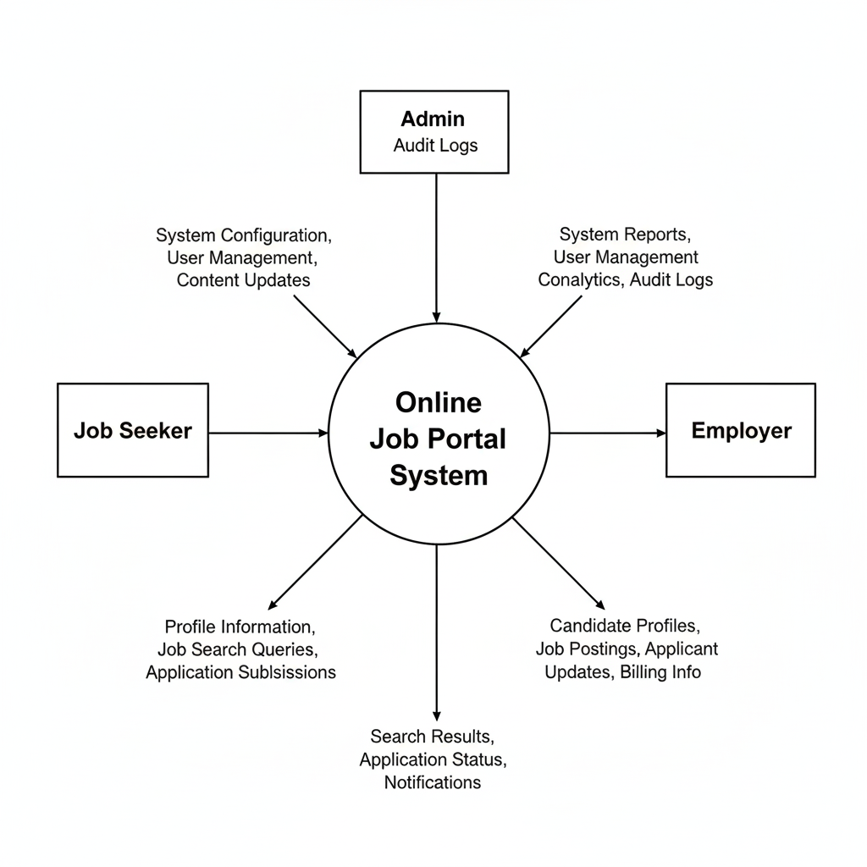

FIRST LEVEL DFD
First level DFD of a system gives a broad picture of all the process of the system and the data transformation within the system.

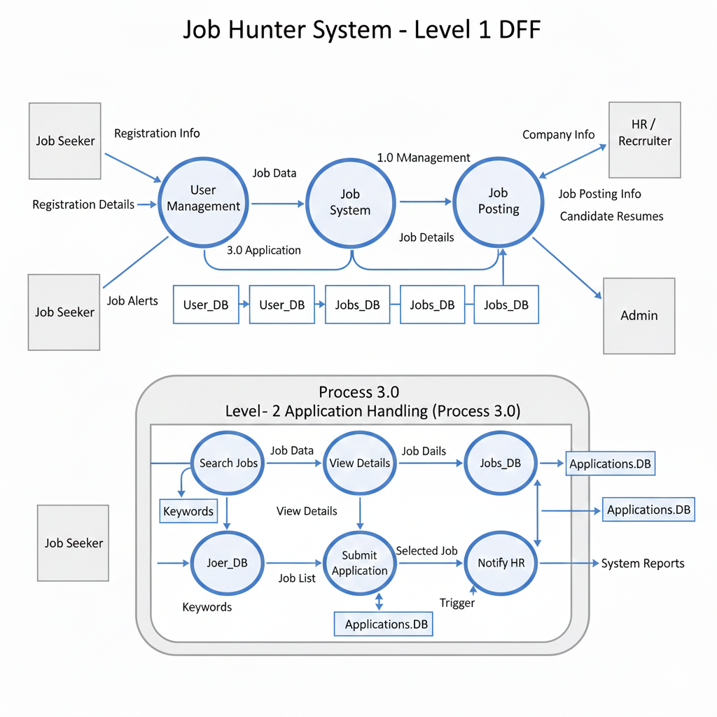

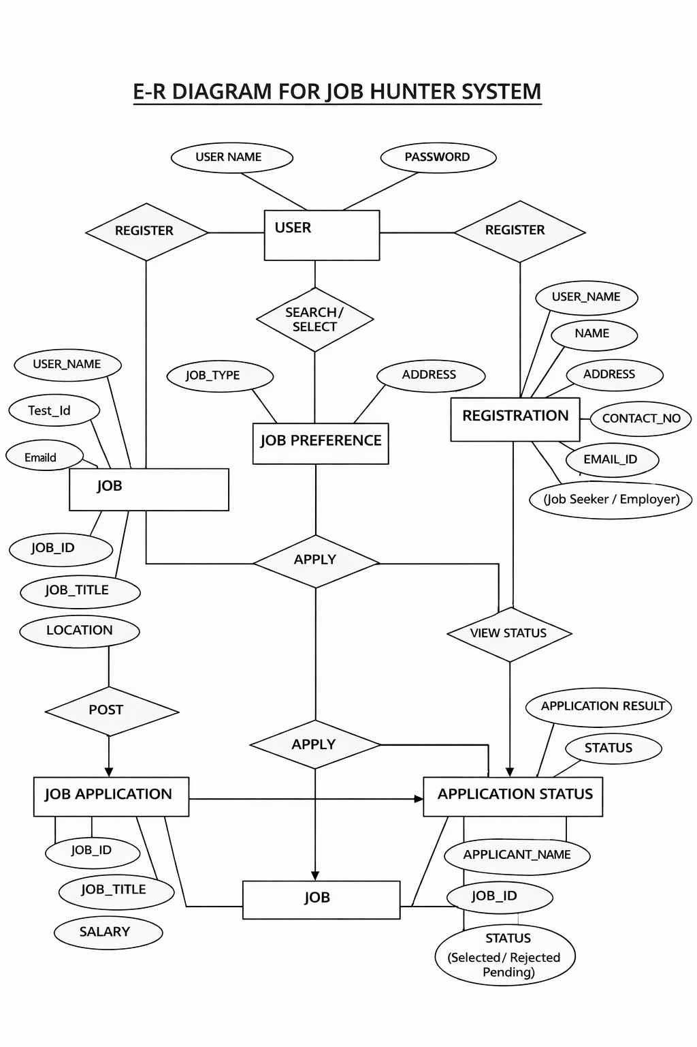

DATA MODELING
USERS Collection
Field Name | Data Type | Description
_id | Object Id | Primary key (auto)
username | String | User login name
password | String | Encrypted password
role | String | job_ seeker / employer / admin
Created At | Date | Account creation date

REGISTRATIONS → USER_PROFILES Collection
Field Name | Data Type | Description
_id | Object Id | Primary key
User Id | Object Id (ref: users) | Link to Users
Name | String | Full name
address | String | User address
Contact No | String | Mobile number
email | String | Email address

JOBS Collection
Field Name | Data Type | Description
_id | Object Id | Job ID
Job Title | String | Job title
Company Name | String | Employer company
Location | String | Job location
Salary | Number | Offered salary
Experience Level | String | Fresher / Mid / Senior
Employer Id | Object Id (ref: users) | Job posted by
Created At | Date | Posted date

PROJECT PLANNING AND SCHEDULING
Gantt chart:
Gantt charts are a project control technique that can be used for several purpose including scheduling and planning. Gantt chart is also known bar chart with each box representing an activity.
The given Gantt chart Show the all activities according their time consuming.

Task | 01 Jun – 5 Jun | 5 Jul – 17 Jul. | 18 Jul. –13 Aug | 14 Aug-28 Aug | 1 Sep.- 25 Sep | 26 Sep- 1 Oct
Preliminary Investigation
Feasibility Study
Requirement Analysis
Design
Coding
Testing
Implement

Pert chart:
PERT stands for program evolution and review technique. A PERT chart is a network of boxes and arrows. The boxes in the pert chart can be decorated with starting and ending dates for activities. PERT chart aid in project is to determining the critical path of tasks and help in completing the project within a given time frame.

Preliminary Investigation
Feasibility Study
Testing
Requirement Analysis
Coding
Design
Implement

PROCESS LOGIC – JOB HUNTER

Login Module
This is the first module of the Job Hunter System.
- The user enters username and password.
- The system verifies the credentials from the Users collection (MongoDB).
- If the username and password are valid, the system allows the user to log in successfully.
- If the credentials are invalid, an error message is displayed.

New User (Registration) Module
This module is used for new users.
- The user enters the required registration details such as name, username, password, contact number, and email.
- The system validates the entered data.
- The user details are stored permanently in the Users and User Profile collections.
- After successful registration, the user can log in using the registered username and password.

Job Selection Module
This module allows users to search and select jobs.
- The user selects the job category or job title based on interest.
- The user selects the experience level or job type.
- The user clicks on the Search button to view available jobs.

Job Application Module
This is the main module of the Job Hunter System.
- The system displays a list of available job opportunities with details.
- The user views job descriptions and selects a job.
- The user clicks on the Apply button to submit the job application.
- The user can search for another job by returning to the Job Selection Module.
- The user can log out or register a new user by returning to the New User Module.

Application Status Module
This module is used to track application progress.
- The user views the application status (Applied / Selected / Rejected).
- The system retrieves application details from the Job Applications collection.
- The user can apply for additional jobs or exit the system.

User Details Module
This module is used to manage and view user information.
- The user selects the User Details option.
- The user enters a valid username and password.
- The system displays the user profile details such as name, contact number, email, and role.

Application Status Module
- This module is used to update and view the status of job applications.
- The system decides whether the application status is Applied, Shortlisted, Selected, or Rejected.
- The module accepts the User_ID and displays the application status details for the given user.

Security Module
This module handles the security features of the Job Hunter System.
- The system checks for unauthorized login attempts.
- It prevents unauthorized access, deletion, or modification of records.
- Access permissions are defined using role-based authorization (Job Seeker, Employer, Admin).
- Secure authentication is implemented using encrypted passwords and JWT tokens.

TYPES OF REPORT GENERATION
The proposed system generates the following reports.
➢ List of all registered users
This report displays details of all users such as username, name, role (Job Seeker / Employer), contact information, and registration date.
➢ List of all job postings
This report shows job details including job title, company name, job location, experience level, and date of posting.
➢ User-wise job application report
This report provides complete details of job applications submitted by a user, including applied job details and application status (Applied / Shortlisted / Selected / Rejected).

FUTURE SCOPE
The Job Hunter System can be further enhanced in the future to improve functionality and user experience. Some of the possible future enhancements are listed below:
- Integration of AI-based job recommendation system based on user skills and preferences.
- Addition of resume parsing and skill matching features.
- Implementation of online interview scheduling and notifications.
- Integration of email and SMS alerts for job updates and application status.
- Development of a mobile application for better accessibility.
- Inclusion of company reviews and ratings.
- Support for multi-language users.

Limitations of the Project
Although the Job Hunter System has been designed to be flexible, user-friendly, and efficient, certain limitations are unavoidable in the current version of the software:
- The system may not include all advanced features that some recruiters or job seekers might require, such as AI-based job recommendations or skill assessments.
- Real-time multi-user operations can be limited depending on the server capacity and internet connectivity.
- Reporting features such as exporting data in PDF, CSV, or other formats are not yet implemented.
- The system’s performance is dependent on the availability and stability of the internet connection. In case of network issues, access may be restricted.
- The current version does not support distributed or enterprise-level deployment, making it unsuitable for very large organizations with multiple branches.
- Mobile responsiveness and cross-browser compatibility may have minor issues in certain environments, which could affect user experience.
- File upload limits for resumes or documents may restrict very large files, requiring additional configuration for large-scale usage.
- Some intricate or optional features, like automated interview scheduling or integration with third-party HR software, are not included in this version.
Despite these limitations, the Job Hunter System provides a strong foundation for online job searching and recruitment and can be enhanced in future versions to overcome these constraints.

Conclusion
In this project, the focus has been on developing an automated system that replaces traditional manual recruitment and job application processes. The Job Hunter System is not just a platform for job searching; it provides intelligent features for managing applications, profiles, and communication between job seekers and recruiters efficiently.
The system enables recruiters and organizations to post job vacancies, track applications, and shortlist candidates with minimal manual effort. Job seekers can create profiles, upload resumes, search for suitable opportunities, and receive real-time updates on their application status. This automation significantly reduces time, paperwork, and operational costs, while improving transparency and accuracy in the recruitment process.
Although primarily designed for recruitment and job searching, the system can be extended for other purposes, such as internship applications, placement drives, online interviews, and other hiring-related assessments. Overall, the Job Hunter System provides a reliable, scalable, and user-friendly solution for modern recruitment needs, and it lays a strong foundation for future enhancements and integration of advanced features.

Bibliography

Books
- Herbert Schildt, The Complete Reference JavaScript, McGraw-Hill, Reprint 2008.
- Roger S. Pressman, Software Engineering: A Practitioner’s Approach, McGraw-Hill.
- Elias M. Awad, System Analysis and Design, 5th Edition.
- Luke Welling & Laura Thomson, PHP and MySQL Web Development, Addison-Wesley Professional (for understanding web application concepts).
- David Flanagan, JavaScript: The Definitive Guide, O’Reilly Media.

Web References
- https://reactjs.org – Official React.js documentation.
- https://nodejs.org/en/docs/ – Node.js documentation.
- https://expressjs.com – Express.js official guide.
- https://www.mongodb.com/docs/ – MongoDB official documentation.
- https://www.tutorialspoint.com/mern_stack – MERN Stack tutorials.
- https://www.w3schools.com – General web development tutorials.

